Tracking Assistant Using Nordic nRF52

Authors Name/s per 1st Affiliation (Author)
line 1 (of Affiliation): dept. name of organization
line 2-name of organization, acronyms acceptable
line 3-City, Country
line 4-e-mail address if desired
Authors Name/s per 2nd Affiliation (Author)
line 1 (of Affiliation): dept. name of organization
line 2-name of organization, acronyms acceptable
line 3-City, Country
line 4-e-mail address if desired

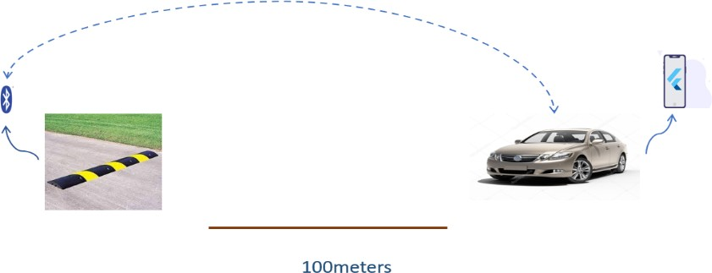
Abstract—The recent development in the hardware component of RF communication technology has helped to detect road signs. Nowadays, accidents occur due to not following road signs and lack of knowledge about the road signs while driving in a car or other vehicles. Which causes injuries to humans and loss of life. The main objective of the project is to prevent accidents from occurring due to not following road signs. Thus, the proposed system will help people to know about the road signs as voice notification prior to 100 meters of the road signs. Here the proposed prototype will be developed using RF communication technology which is based on an nRF52832 microcontroller with embedded BLE [Bluetooth Low Energy ]. Each Bluetooth module [nRF52832] is placed in the place of road signs like speed breakers, hospital zone, prohibited zone, and other necessary road signs and it is powered using solar power at the transmitter side. On the receiver side, a user-friendly application is developed using the flutter framework which would help user to get a prior notification about the road signs. Thus, the analysis where made on different types of road signs to be notified of any climate conditions.
Keywords: RF communication, BLE, nRF52832 , Flutter Framework, Road Signs

INTRODUCTION
Road transport remains the most favored mode of transport for both freight and passenger movement in India. The fast-growing population, exceptional rate of motorization coupled with the ever growing urbanization has made people vulnerable to frequent road accidents resulting in fatalities, injuries/disabilities. Road accidents in India kill almost 1.5 lakh people annually. Accordingly, India accounts for almost 11% of the accident related deaths in the World. And around 1.37 lakh accidents occurs in National Highway. The main aim is to reduce the accident which occurs due to overspeed of the vehicles. And to create awareness among people to follow the people to follow the road signs. It would tell about the road sign in prior before 100 meters. The project can also be implemented in autonomous car which would be an added advantage for accurate detection and the misguiding of the road sign will never occur in the future. Where it uses the RF communication technology i.e. BLE 5.0 module at the transmitter end , which is placed near the road sign and it is powered via solar panel , where at the reception end it uses the flutter framework based app which can be installed in android as well as IOS devices and it will give voice notification to the users about the road signs in prior.

CONCEPT OF WORKING
This project will work using RF communication technology under 2.4GHz using the Bluetooth technology. Where we have used the high range Bluetooth module and it should be constantly powered under 3.3V which is done using the renewable source of energy i.e. the solar panel, and it named via nRFDK and J-link to give unique key for road signs. On the other side which uses the Flutter framework for application development , and it can be used in all types of platform independent of the operating system. This works on the condition similar to our wifi when it scans if the visibility of the device occurs it just gives the corresponding voice message to the user about the respective road signs as the sign of prior indication about the road signs. In the simple words to say it works just like if condition in the C program, it does not pair with the device it just checks whether the unique key is available or not and responds according to it. And at a time it can responds more than seven devices, and which does not have any restriction in the limitation of the devices.

BLOCK DIAGRAM
The flow of control of the transmitter will start from the power control unit which consist of 6 volt solar panel, a battery management system and a Lithium Polymer battery of 3.7 volt. And the flow of control will goes to Bluetooth Module Bm832A which has an inbuilt microcontroller and the last unit of the transmitter side is the Antenna unit where we have used the Spiral helical antenna for the purpose of long range communication. The flow for the receiver will start from the Mobile or any other devices which is based on IOS or Android platform and then the flow will go to the Bluetooth sign app which is developed using Flutter framework and the last unit which will be the voice notification section.

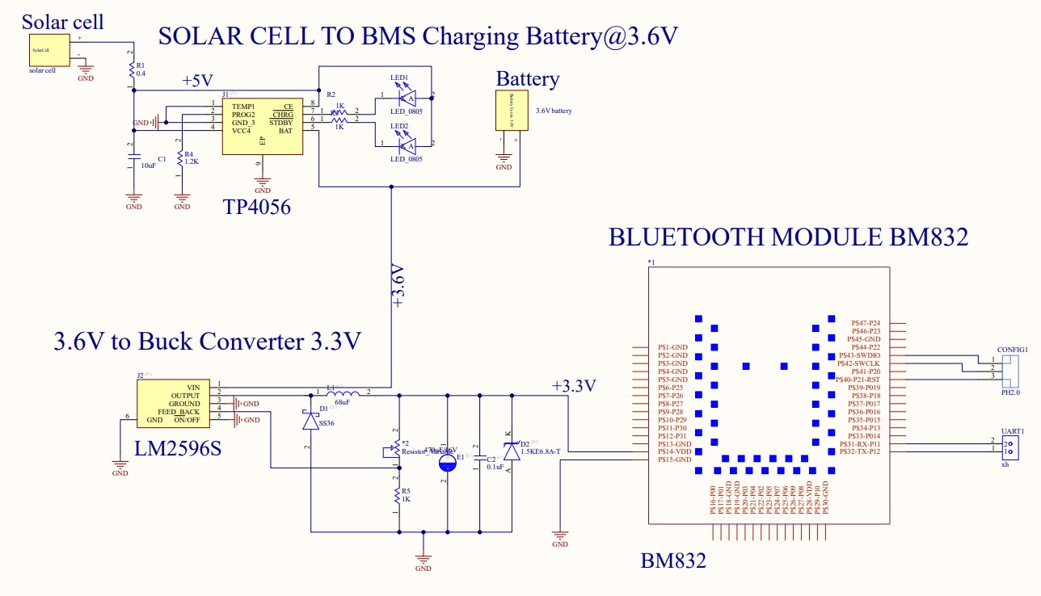
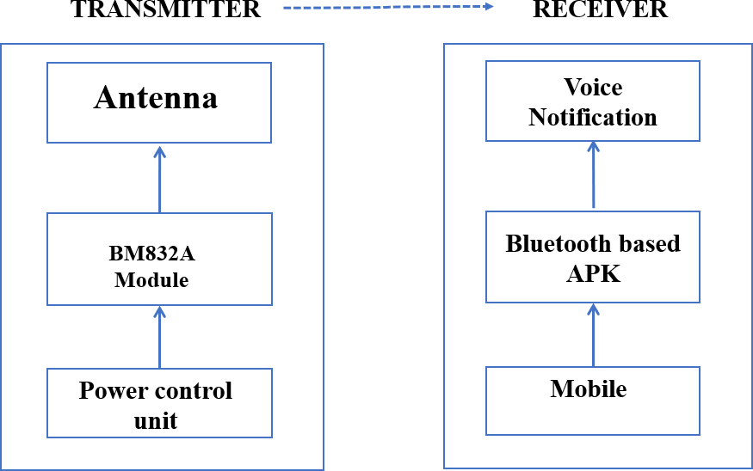

DESIGNING OF PCB USING ALTIUM
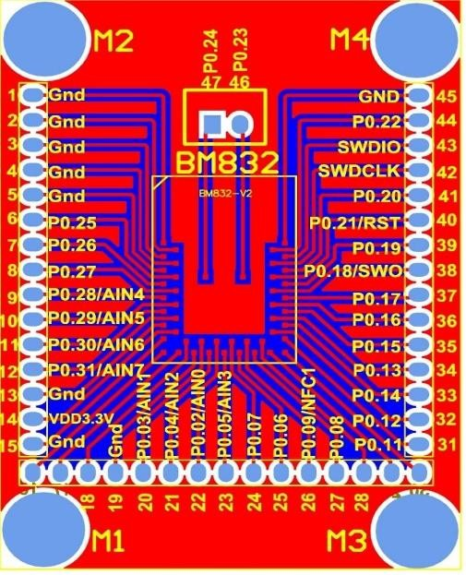
Altium Design is a PCB and electronic design automation software package for printed circuit boards. It is developed by Australian software company Altium Limited. Altium Designer's suite encompasses four main functional areas, including schematic capture, 3D PCB design, field-programmable gate array (FPGA) development and release/data management. It integrates with several component distributors for access to manufacturer's data. It also has interactive 3D editing of the board and MCAD export to STEP. Where the design trace and pinout of BM832A has been used here from the Fastel brand website. And then which is developed using the Altium Software, which can be prevented from affecting pins of the Bluetooth module. Where the Fig. 4.11 describes the Pcb board design using Altium.

CIRCUIT DIAGRAM
The hardware design of the transmitter side is described here using the circuit diagram representation, where the solar panel is a 6 volt panel where continuously charging and discharging occurs simultaneously to increase the life time of the battery and maintain the battery health we have used the Battery Management System , which is connected to the battery which the battery charges nearer to 5 volt and discharge 3.7 volt since the Bluetooth module requires only 3.3 volt , in order to reduce the voltage the Buck converter is used for the conversion of 3.7 volt to 3.3 volt which is a DC to DC converter , then the Bluetooth module is powered continuously at 3.3 volt and from the pcb trace antenna we can use the additional antenna for effective ranging, the circuit diagram is shown below

RECEIVER SIDE USING FLUTTER

Since this app is developed in flutter it can be used in both Android as well as the IOS based devices. And the code which is written in the dart programming language and others for effective detection. Here we have introduced the new concept of not paring with the transmitter, and can respond immediately without paring. Where at the transmitter module has been named with the unique key which cannot be decrypted, if the receiver module comes into the range of the transmitter, it just compares with the key which is given in the if condition of the program and responds accordingly by giving voice message as notification to the user. Where the code is developed in Android Studio using Flutter framework and dart language.

RSSI PARAMETER
RSSI stands for Received Signal Strength Indicator. It is the strength of the signal as on the receiving device, e.g. a smartphone. The signal strength depends on distance and Broadcasting Power factor RSSI is used to approximate distance between the device and the Bluetooth using another value defined by the iBeacon standard: Measured Power. Due to external factors influencing radio waves such as absorption, interference, or diffraction RSSI tends to fluctuate. The further away the device is from the Bluetooth, the more unstable the RSSI becomes.

MEASURED POWER
Measured Power is a factory-calibrated, read-only constant which represents the expected RSSI at a distance of 1 meter to the beacon. Combined with RSSI, it allows to estimate the distance between the device and the other Bluetooth device. However, you can change it in the raw chips using Arduino and other controller if you have access to the AT-commands of the BLE chip. The measured power the Bluetooth BM832A is -83.00 dB. And RSSI is calculated from the measured power.

FORMULA FOR DETERMINING RSSI & DISTANCE
The Formula is obtained from the Distance, Measured Power and the RSSI. The distance is calculated using the formula, Distance = 10^ ((Measured Power – RSSI)/(10 * N)) where the N represents is Constant which depends on the Environmental factor. Range 2-4 . Measured Power is also known as 1 Meter RSSI. The measured power the Bluetooth BM832A is -83.00 dB. Obviously, the Distance calculated is the approximate distance and not the exact distance as for calculating exact distance we have to make the loss factor (from environmental factors) is zero.

FLOW PROCESS IN FLUTTER
Scanning of the Bluetooth - where the scanning is initiated for a second. Searching for the device – where the scanning result is given as input to this, and then comparison takes place. Calculation of the Distance and the RSSI. Responding to the scanned input, where the output is given as voice notification to the user for three times, and the process of scanning starts from the beginning.

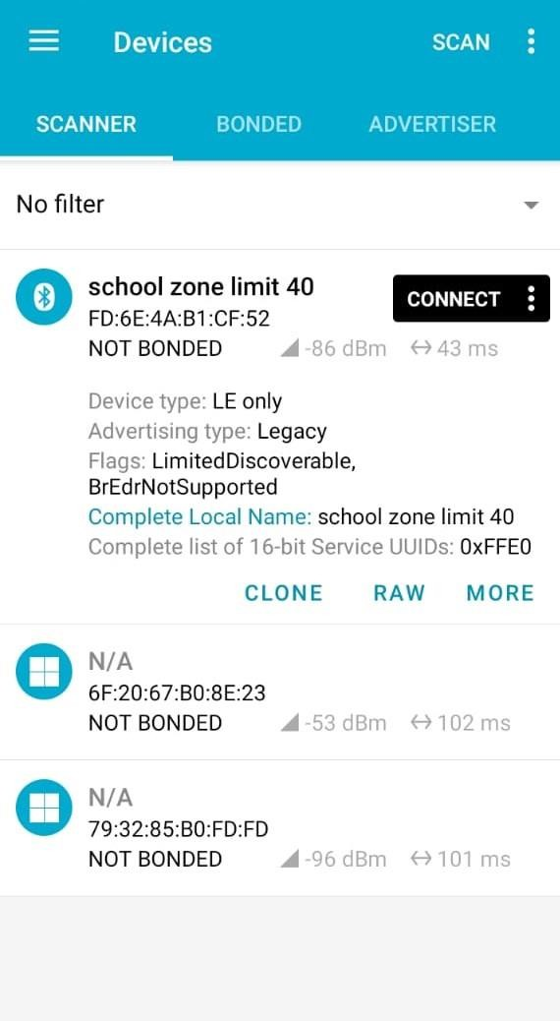

RESULT ANALYSIS

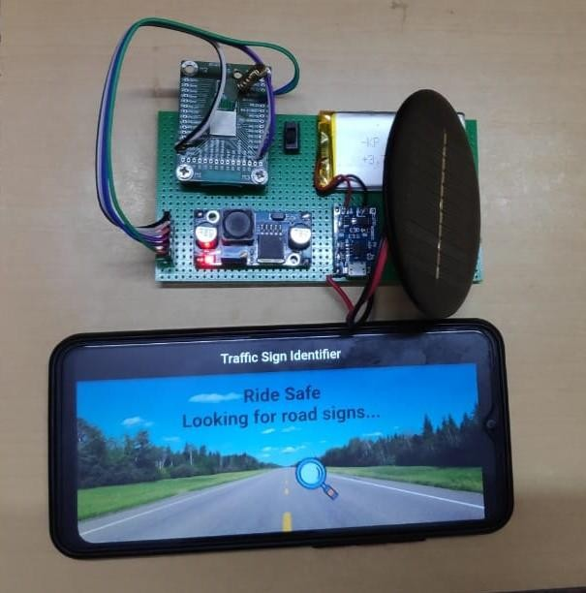

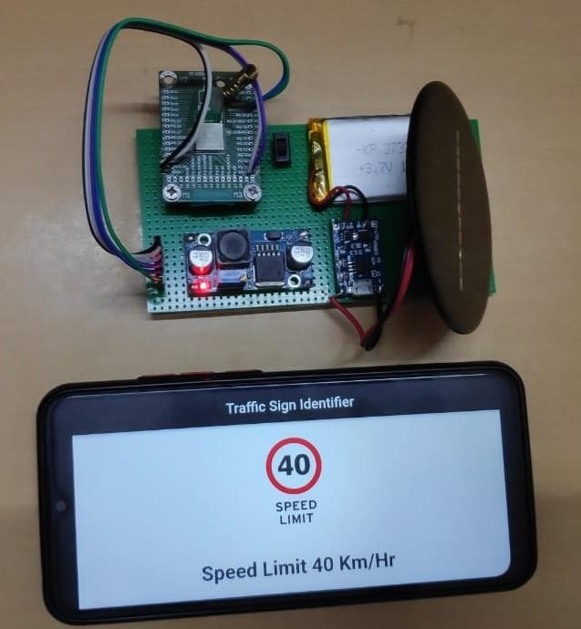

CONCLUSION AND FUTURE SCOPE

CONCLUSION
This project has laid down a new way of detecting the road signs in a different manner in the field of Transportation. The proposed system will help the users in detecting all types of road signs prior about 100 meters and it can be used in any types of vehicles, which can help more number of users at any instant of time. The specialty of this project it can also be used in the Department of Tourism for the tourist to guide and then it does not behave like normal Bluetooth where it works without pairing and also help users in giving voice notification with images in their display. In this way the majority of the accidents which occurs in the National Highway and also the death rates can be reduced.

FUTURE SCOPE
As of now, we have come up with the detection of road signs in prior with the help of Mobile phones , but in future the application can be made has an inbuilt feature of the car because it has an display unit, and just we need to install the app. In future to increase the range of the Bluetooth an external long range antennas can be used, and can work more efficiently than today. In future it can also be implemented in autonomous cars has an added advantage in finding out the road signs without any confusion even though there are similarities in the road signs.

References
- Domen Tabernik , Danijel Skoˇcaj,” Deep Learning for Large-Scale Traffic-Sign Detection and Recognition ” , Volume: 21, Issue: 4, pp. 1427 –1440, April 2020.
- Aleksej Avramovic , Davor Sluga , Domen Tabernik , Danijel Skoˇcaj, Vladan Stojni, and Nejcilc, “Neural-Network-Based Traffic Sign Detection and Recognition in High- Definition Images Using Region Focusing and Parallelization “, IEEE Access Volume: 8 , pp. 189855 - 189868, October 2020
- Victor Ciuntu, Hasan Ferdows ,“ Real-Time Traffic Sign Detection and Classification Using Machine Learning and Optical Character Recognition”, (IEEE International Conference on Electro Information Technology (EIT) ), 1 Aug. 2020
- Junyao Guo , Unmesh Kurup, and Mohak Shah ,“Is It Safe to Drive? An Overview of Factors,Metrics, and Datasets for Driveability Assessment in Autonomous Driving “ ,Volume: 21, Issue: 8, pp. 3135 - 3151 , Aug. 2020

- Dominik Grochala, Marcin Kajor, Michał Grochala, Paweł Smoleń, Marek Iwaniec, Justyna Lemejda, “Sensitive Data Transmission System for Biopotential Measurements in Wearable Application”, 2020 IEEE XVIth International Conference on the Perspective Technologies and Methods in MEMS Design (MEMSTECH) , June 2020
- Shi-Cho Cha, Ming-Shiung Chuang, Kuo-Hui Yeh , Zi-Jia Huang, Chunhua Su, “A User-Friendly Privacy Framework for Users to Achieve Consents With Nearby BLE Devices “ , IEEE Access ,Volume: 6 , pp: 20779 – 20787 , March 2018
- Gerrit Maus , Dieter Brückmann, “A non-intrusive, single-sided car traffic monitoring system based on low-cost BLE devices”, 2020 IEEE International Symposium on Circuits and Systems (ISCAS), September 2020
- Bingqing Luo, Yudong Yao, Zhixin Sun, “Performance Analysis Models of BLE Neighbor Discovery: A Survey” , IEEE Internet of Things Journal ,Volume: 8, Issue: 11, pp: 8734 – 8746, June 2021.
- Yi Yang, Hengliang Luo, Huarong Xu, and Fuchao Wu ,” Towards Real-Time Traffic Sign Detection and Classification”, IEEE Transactions on Intelligent Transportation Systems, Volume:17, Issue: 7, pp:2022 – 2031, July 2016.
- Mayur R. Deogade, Harshal Belan, Milind Rane, “Range Performance Validation Trials by changing RF Data Rate”, 2019 IEEE 5th International Conference for Convergence in Technology (I2CT), March 2019.
- Kang Eun Jeon, James She, Perm Soonsawad, and Pai Chet Ng, “BLE Beacons for Internet of Things Applications: Survey, Challenges and Opportunities” , IEEE Internet of Things Journal , Volume: 5, Issue: 2, pp: 811 – 828 , April 2018.
- Da Li, Bodong Liang, Weigang Zhang, ” Real-time Moving Vehicle Detection, Tracking, and Counting System Implemented with OpenCV ”, 2014 4th IEEE International Conference on Information Science and Technology, April 2014.
- Gaoyang Shan, Geunkyoung Choi, Byeong-hee Roh, Jinsuk Kang,”An Improved Neighbour Discovery Process in BLE 5.0” 2019 IEEE 10th Annual Information Technology, Electronics and Mobile Communication Conference (IEMCON), October 2019.
- Dogancan Temel, Min-Hung Chen, Ghassan AlRegib, “Traffic Sign Detection Under Challenging Conditions: A Deeper Look into Performance Variations and Spectral Characteristics”, IEEE Transactions on Intelligent Transportation Systems ,Volume: 21, Issue: 9, pp: 3663 – 3673, September 2020.
- Yujun Zeng, Xin Xu, Dayong Shen, Yuqiang Fang, Zhipeng Xiao,“Traffic Sign Recognition Using Kernel Extreme Learning Machines With Deep Perceptual Features”, IEEE Transactions on Intelligent Transportation Systems, Volume: 18, Issue: 6, pp: 1647 – 1653, June 2017.

